What is Resume Optimization?
Resumes are critically important. Hiring business leaders and organizations require a resume and anticipate adherence to typical formats, truth and completeness.
You don’t realize how much stronger and more compelling you can present yourself! You believe you have a strong resume, yet it can be exponentially better in just 20 minutes. And so you accept less opportunity, less remuneration, less influence using the resume you’ve always used, the one your university career center helped you create or your colleagues, friends or partner helped you write.

Your resume’s job is to speak for you, transferring the best information about you from the page into the reviewer’s mind so quickly and effectively it’s like they simply absorbed it, convincing them to choose you.

How can you do that? Use Tom Mihok’s Resume Optimization strategies and techniques.

Critical: Write for Fast Absorption and More Complete Review of Information

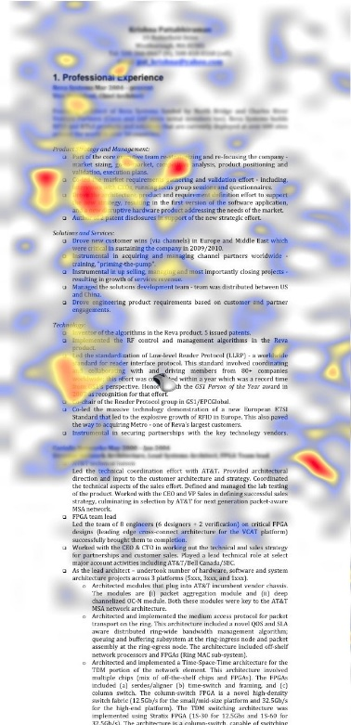
Some say you have six seconds to convince a reader to choose your resume. Look at the resume below left (source: The Ladders). It depicts a heat map following the eyes of someone reading it. Red indicates a concentrated, lingering review of the information, yellow mild concentration and blue scanning only, eyes wandering over the page.

The left resume’s format consists of a dense column of information that runs straight down the page, has very little white space, no section designations, no prioritization or bunching of information and very little use of cascading (e.g.--bold, italics, all capitals, indentations) that help the reader absorb the information more quickly and efficiently.

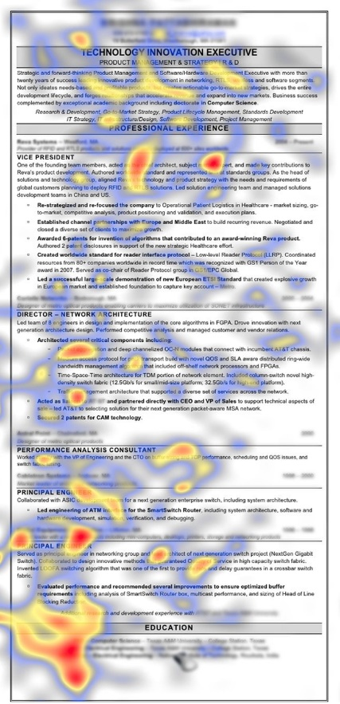
Result? Only five spots where the eye lingers (red, primarily top and left of the page) and otherwise the eye wanders, aimlessly (yellow and blue, again primarily top and left). There is a low percentage of red to blue. Important experiences or achievements lower and right on this resume? The reader won’t see them. The reviewer won’t learn much about the candidate from the resume’s construction so they receive no consideration and little time under discussion by potential hirers.

Compare to the resume at the right (source: The Ladders). It uses sections (indicated by gray fill and lines across the page with titles in all caps and bold) to guide the reader to what the candidate wants seen. It uses cascading with bolding, indentations, bullets, all capitals and upper and lower cases to help the reader absorb the information and determine quickly the relative importance of items. It has abundant, strategic white space.

This resume writer understands that readers read left to right, top to bottom and takes advantage.

Notice there are many spots where the reader’s eyes concentrate (red), these areas tend to be at the top of a section and they extend to the bottom of the page (lots of focus on Education at the left side—probably looking at degrees). There is much less blue and a high percentage of red to blue--important differences.

These techniques motivated the reader to review more of the page, covering more of its geography (from top all the way to the bottom, left and all the way to the right) and focusing on more of the valuable information the candidate wants understood. The reviewer could almost absorb the information by scanning the page.

How Magazine Ads Influence Resume Optimization Strategies
In the classroom where Resume Optimization is part of the Career Aspects of Personal Finance chapter I’ve taught for ten years, I show students magazine ads. I face a student, open the magazine to an ad like the one to the left (source: BBC.co.uk), hold it open for only an instant, then--close it quickly! One second only! I get some laughs and smiles in surprise from the class.

Then I ask the student what they saw. They almost never miss. For the ad to the left, a typical response would be, “Roger Federer, Rolex watch, large Federer and Rolex watch images, few words on the page.”

I do this multiple times with other advertised items: cars, luggage, furniture, beverages. The result is always the same—students almost never miss what they saw with only a moment’s glance.

This is not meant to convince you to imitate the ad copy for luxury goods with your resume. It is to convince you that there are techniques that work to improve the chances of your resume being read, your talent more completely understood and resume chosen over others even when you only get a moment’s review.

How We Improve Resumes

Similar techniques and strategies work for resumes. See the testimonials on our webpage. People say, “I was getting no attention with my resume. No return contact. Soon after using your techniques I began getting interviews.”

We place high emphasis on prioritization and location of information, putting the most important top and left. The first bullet in a section is the writer’s greatest accomplishment related to that section, then the second and third (regardless of when they occurred). The most important information in a sentence appears early, at the beginning of each bullet (nearest to the bullet), they list their achievements (not their duties) and do this with personal activities and interests they present too.

Writers build bulleted sentences that tell stories directly communicating context, size and scale of achievement, talent, earned experience and effort. These achievement stories infer—without stating them in writing and so saving space--the candidate is loyal, hard-working, ethical, dedicated, a fast learner, team player—all personal characteristics evaluators want. They do double duty in less space.

Sample additional techniques Resume Optimization uses:
- Hierarchy of bullet content, in order of least to most impactful: (1) duties; (2) achievements; and (3) stories
- CEOs, organization leaders and salespeople use stories. Stories communicate context, challenge, accomplishment, personal characteristics—in less space.
- Get the reader to absorb information from your resume, like reading a book on vacation—from the page to the readers’ brain.
- Make it easy to absorb information and determine your talent from your resume. Too difficult or time-consuming and the reader won’t do it! Make it easy.
- Re-write experience headings and bullets under them to put the most important information top and left.
- Scrutinize your bulleted sentences. Reorganize the information contained in them so that the most impactful information is first. If what you achieved is at the end of your sentence, preceded by your actions that produced the achievement, the achievement may not be seen.
- Need a summary or objective? We help you determine that.
- More than one page? You need to know your audience and what they’ll expect.
- Go outside the box while still using the expected format: considering bolding your GPA, sales or profit achievements even though uncommon.
- Use numbers and percentages that make favorable impressions whenever possible—they have more impact in less space than narrative.
- Everyone knows the first word in a bulleted description is critical and people still use sleep- inspiring first words that don’t distinguish themselves!
- Getting more senior? Readers of your resume have even less time to digest it because they’re busier themselves.
- You must put your best foot forward with your resume. It’s not a document of humility.

